GETTING STARTED WITH QUICKEN®
2012 - 2010, for Windows®

Refer to this guide for instructions on how to use Quicken’s online account services to save time and automatically keep your records up to date. This guide will be broken up into product versions, please be sure to follow the steps that apply to the version of Quicken you are currently utilizing.

Before you can download your transactions with Quicken you will need internet access, your Bank by Mouse ID and password.
This Getting Started Guide contains the following information:
- Downloading the Latest Quicken Updates- How to download free product updates as they become available for your version of Quicken.
- Creating a New Quicken Account- How to use the Express Setup to create a new Quicken account for downloading transactions and paying bills online.
- Keeping Your Quicken Accounts Up to Date- How to download transactions or send payments with accounts that you have activated for online account services.
- Using Online Bill Payment- How to set up an online payee and create an online payment.

Click the version you are looking for

2011- CREATING A NEW QUICKEN ACCOUNT 2011
2010 - CREATING A NEW QUICKEN ACCOUNT 2010
2009 - CREATING A NEW QUICKEN ACCOUNT 2009

For step-by-step instructions with an online task (or any other Quicken question) go to Help → Quicken Help → select the Search Quick Help tab and type in the topic and click Ask.

DOWNLOADING THE LATEST QUICKEN® UPDATE
(Applies to all product versions)

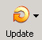
- Click the Update icon on the Quicken toolbar.
- Uncheck all boxes → Update Now in the One Step Update Settings dialog.
- If an update is available, Quicken will provide a description of the update and brief instructions for
receiving the update.
- When the update is completed, close Quicken. Reopen Quicken.
DOWNLOAD OPTION
(Applies to all product versions)

Direct Connect vs. Express Web Connect vs. Web Connect: Quicken offers several methods for you to connect to your financial institution.
- Direct Connect provides a direct connection to your financial institution, and allows you to download transactions, as well as initiate transfers and bill payments directly from Quicken, without having to log into your bank website. Not all financial institutions support Direct Connect. Some financial institutions may charge an additional fee for this service. If you are interested in Direct Connect, please contact your financial institution to activate it before you set up your account in Quicken. Once you receive your Direct Connect login information, enter it in this screen.
- Express Web Connect allows you to download transactions automatically from your bank, but does not enable transfers or bill payments. Your login is the same as what you use to login on your bank website.

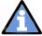
Quicken automatically tries to pick the best method to connect to your financial institution. When you enter a login on this screen, Quicken will try Direct Connect, and if that doesn’t work, will default to Express Web Connect. If that doesn’t work, you will be taken to the login page of your financial institution’s website.

CREATING A NEW QUICKEN ACCOUNT 2011
- To add a new account Launch Quicken 2010 → Click on the Tools drop down menu → then select the Add Account option or Click the Add an Account button
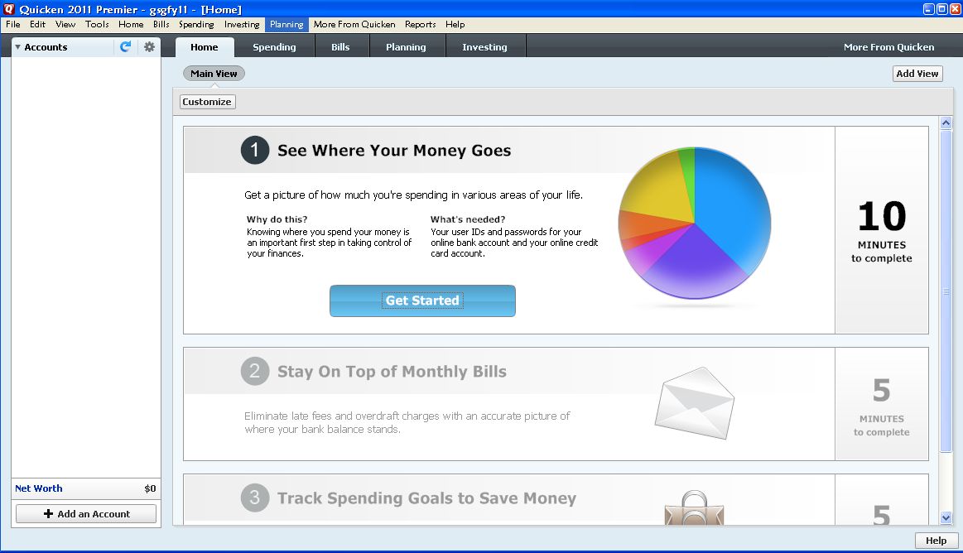

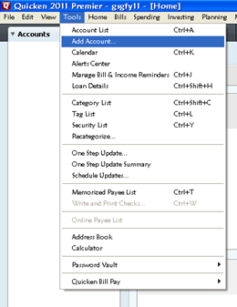

- On the Add Account window select the type of account you will be setting up → Click Next. Enter the name of your financial institution→ then click the Next button.
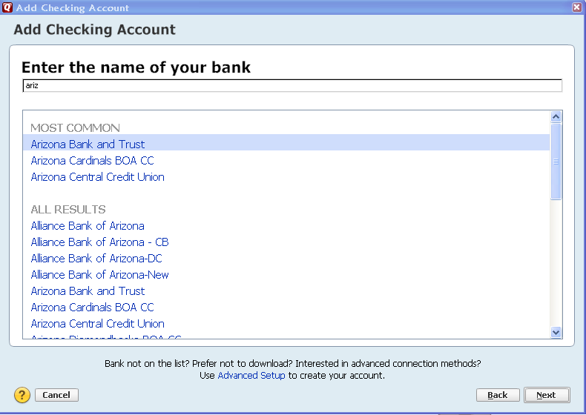

- Enter your customer ID and password (this is usually the same information that you use to login to your financial institution’s web site, however it may differ) → Click Next to continue.
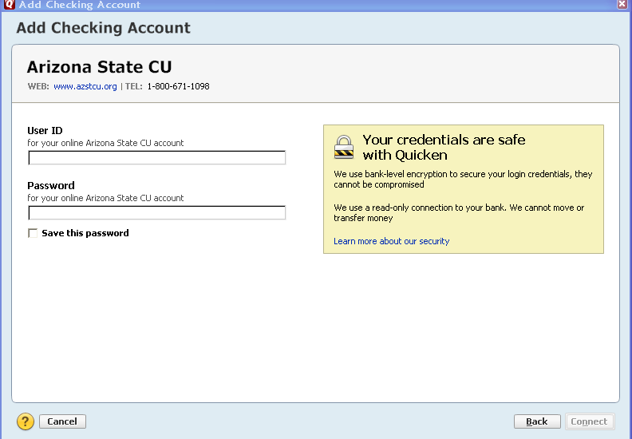

If you are unsure about which ID and password to use, you may want to contact your financial institution.

- All downloadable Quicken accounts display. You can choose to add another account right now or start using Quicken and add more accounts later.
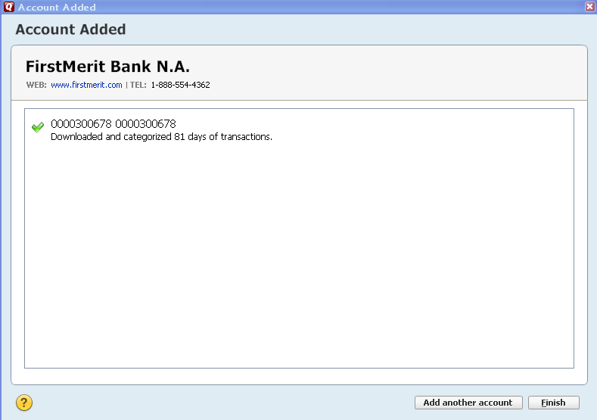

- Quicken will download your transactions and automatically categorize them, so you can quickly see where your money is going.
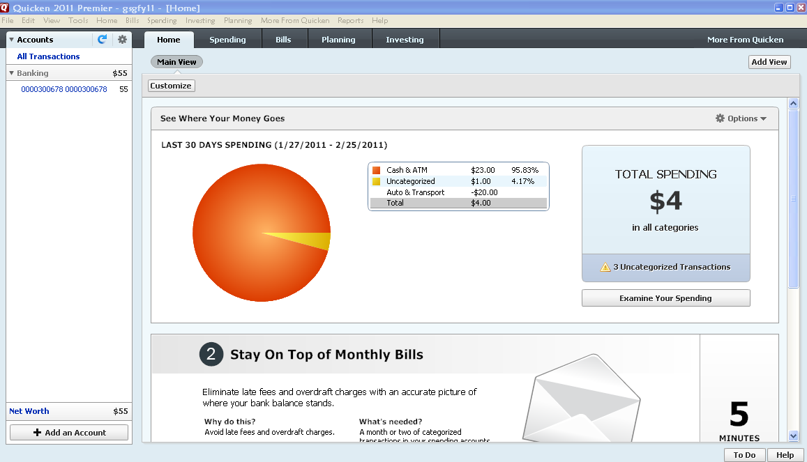

The pie chart on the homepage shows you where you money is going. To review your transactions, click on the account name in blue on the left side of the screen. To add another account, select the “Add Account” button on the bottom left of the screen. To update your accounts, just select the “Update” button at the top left of the screen to download transactions from your bank again.

CREATING A NEW QUICKEN ACCOUNT 2010
- To add a new account Launch Quicken 2010 → Click on the Tools drop down menu → then select the Add Account option.

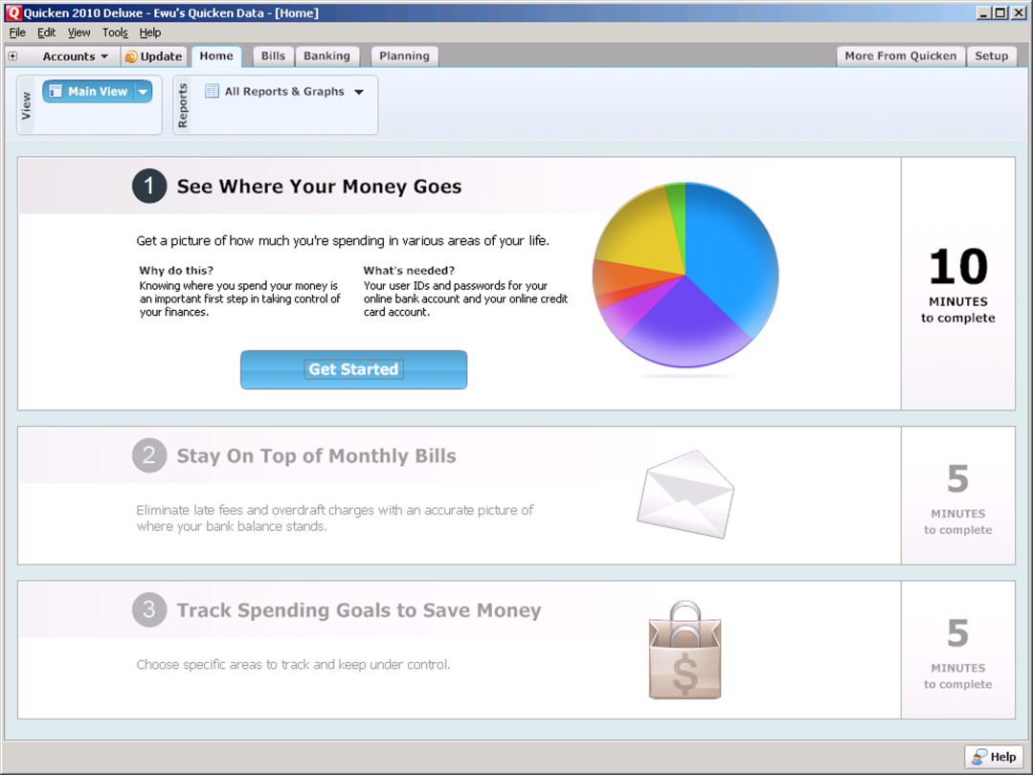
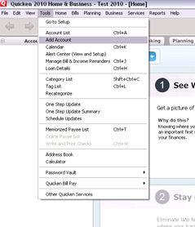

- On the Account Setup screen enter the name of your financial institution→ then click the Next button.
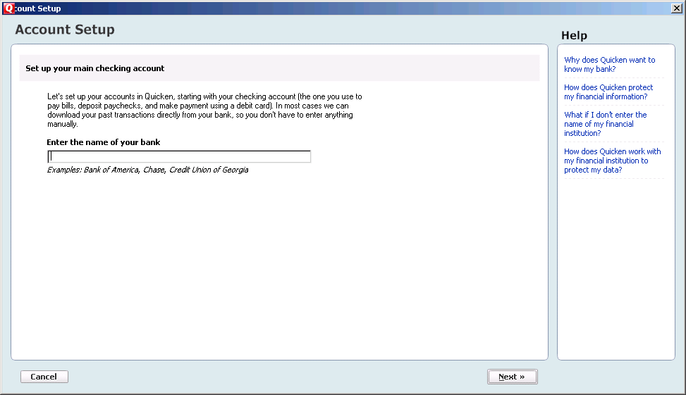

- Enter your customer ID and password (this is usually the same information that you use to login to your financial institution’s web site, however it may differ) → Click Next to continue.
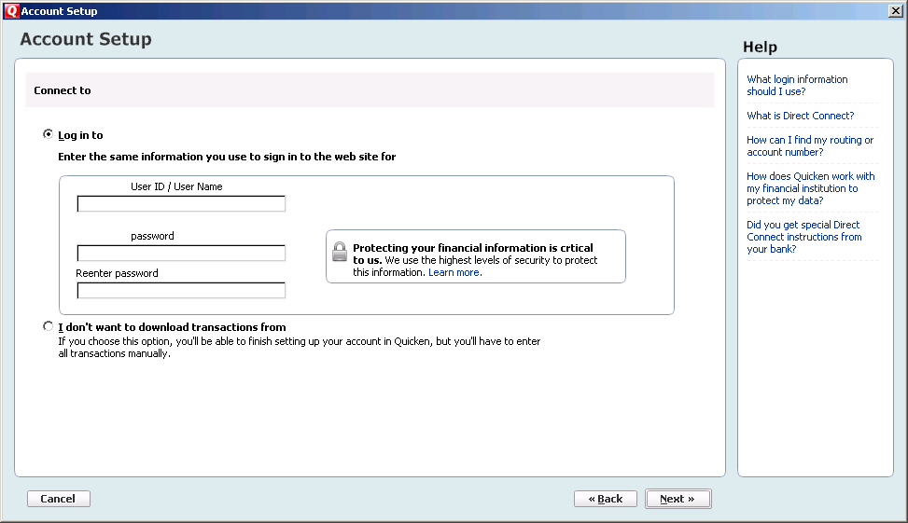
If you are unsure about which ID and password to use, you may want to contact your financial institution.

- All downloadable Quicken accounts display. You can customize the Account Name (to use in Quicken: Enter account nickname) for each account by typing directly in the field.

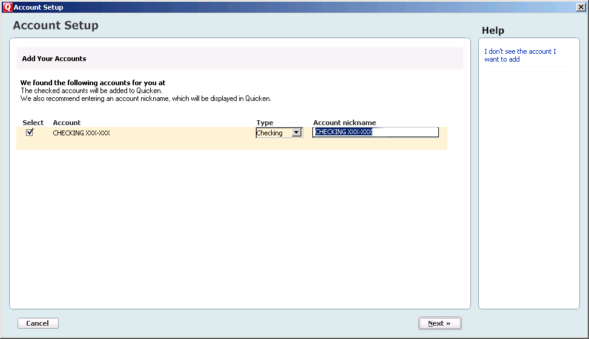
To customize the Account Name in Quicken, enter account nickname

- Confirm the accounts you wish to set up and/or customize Account Name → click Next
- Quicken will download your transactions and automatically categorize them, so you can quickly see where your money is going. You can choose to add another account right now or start using Quicken and add more accounts later.

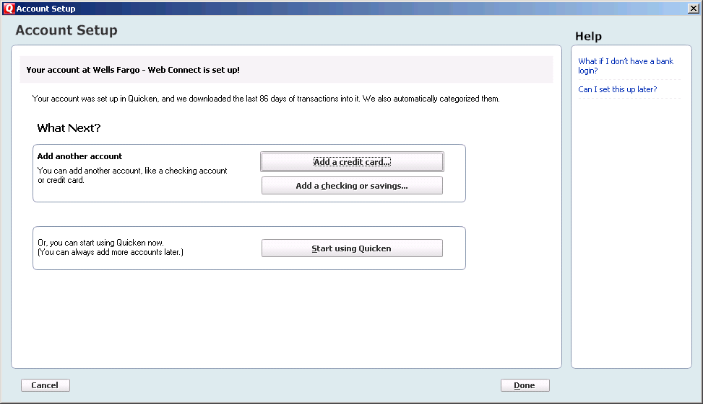

- The pie chart on the homepage shows you where you money is going. To review your transactions, click on the account name in blue on the left side of the screen. To add another account, select the “Add Account” button on the bottom left of the screen. To update your accounts, just select the “Update” button at the top left of the screen to download transactions from your bank again.

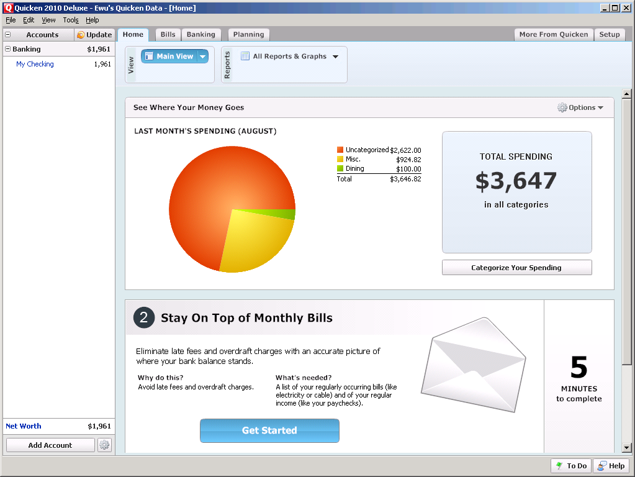

CREATING A NEW QUICKEN ACCOUNT 2009

- Go to Online drop down Menu → Online Account Services Setup → Create New Quicken Account.
- Quicken Windows 2009 version only: Select the account type you are creating → Click Next

When creating a Credit Card account choose Credit Card and Investing/Retirement for brokerage type accounts. For Money market accounts select either Checking or Savings.

- If the account is held at the following institution [Financial Institution Name Goes Here], select from the list provided.
- After you have selected yes to connect to [Financial Institution Name Goes Here] through Quicken, click Next.
- Enter your customer ID and password (your password will need to be entered in a second time for confirmation) Click Next to continue.

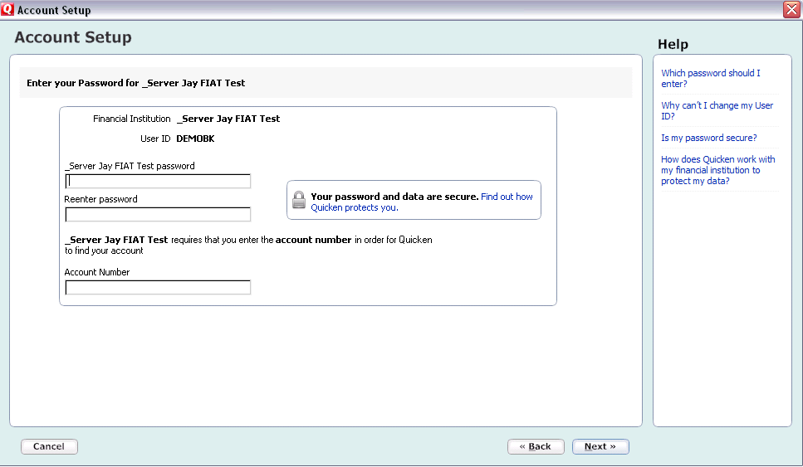
If you are unsure about which ID and password to use, then see the Need a Customer ID and password information to the right.

- All downloadable Quicken accounts display. You can customize the Account Name (to use in Quicken: Enter account nickname) for each account by typing directly in the field.

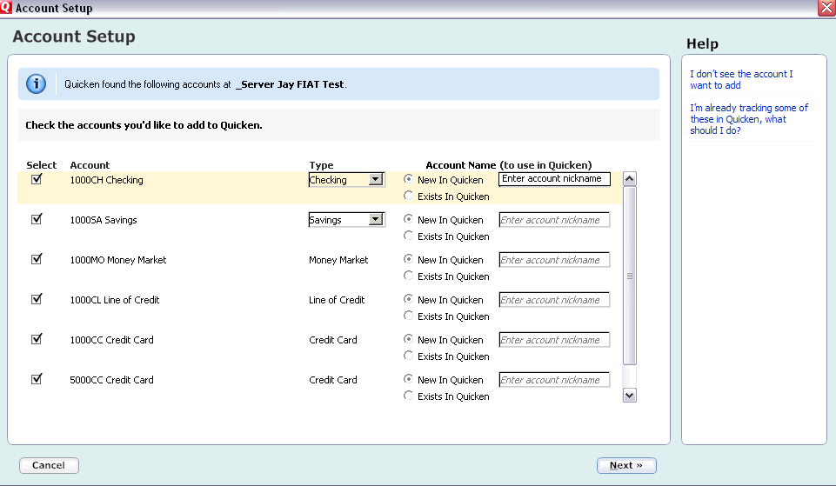
To customize the Account Name in Quicken, enter account nickname

- Confirm the accounts you wish to set up and/or customize Account Name →click Next
- After the Quicken One Step update is completed, you will be prompted to store your password in the Password Vault. Select YES or NO to continue, → Click Next

To learn on the Password Vault, click on What is the Password Vault under the Help menu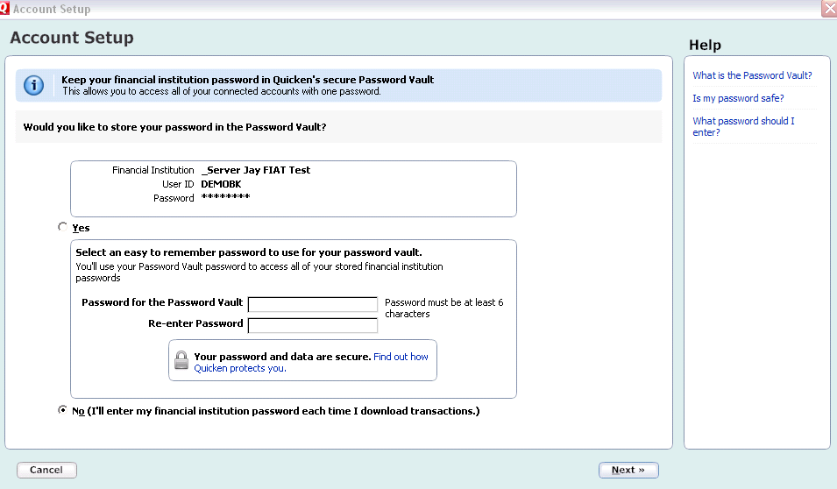u
To keep your password in Quicken’s secure Password Vault select yes.

Summary of accounts added
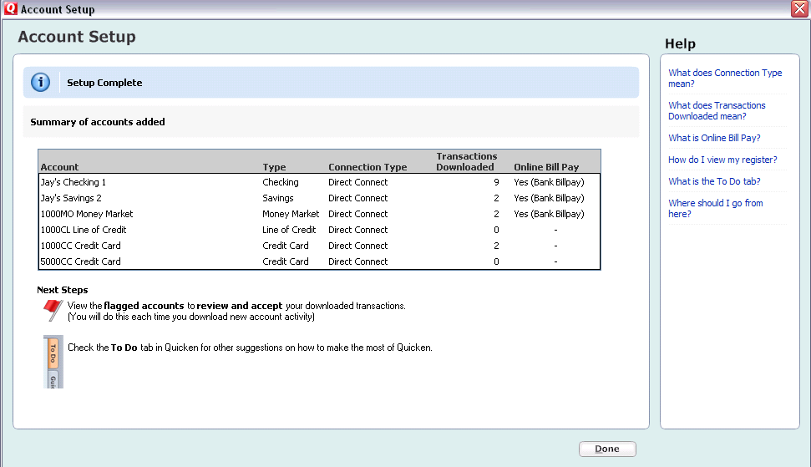

- After reviewing your Account Setup Summary page, Click Done

YOU ARE SET UP AND READY TO USE QUICKEN

