Getting Started with Quicken® 2007 for Mac®
 | Refer to this guide for instructions about using Quicken for Mac’s online account services to save time and automatically keep your records up to date.  Before you can download your transactions with Quicken, you must have Internet access, your customer ID, and password.  For step-by-step help with an online task, choose Help menu → Quicken 2007 Help.  This guide includes the following sections:  - Downloading the Latest Quicken Update—Describes the steps to download free product updates as they become available for your version of Quicken.  - Setting up a Quicken Account for First Time Download—Explains how to create a new Quicken account and download transactions.  - Keeping your Quicken Accounts up to Date—Explains how to download transactions or send payments with accounts that you have activated for online account services.  Note to former QIF import users: Web Connect offers superior download capability. You will enjoy an easier and more accurate download, without having to import and find your file, worry about duplicates, or even manually launch Quicken! You can convert your existing Quicken account to download via Web Connect. If your financial institution offers multiple download options on the Web site, make sure to select .QFX Web Connect. Do not select the older .QIF file format.

DOWNLOADING THE LATEST QUICKEN UPDATE
- Choose Quicken 2007 menu → Check for Updates.
- Follow the on-screen instructions.

SETTING UP A QUICKEN ACCOUNT FOR FIRST TIME DOWNLOAD
The following steps explain how to activate your existing Quicken account(s) or create one or more new Quicken accounts for Web Connect online access.
- Open a Web browser and log into Bath State Bank’s web site: www.BathStateBank.com. Follow the instructions provided on the Web site to download your account information into Quicken.
- When you click Download to Quicken, your browser may prompt you to open or save files. If this prompt appears, click Open and follow the on-screen instructions.
- To set up a new account in Quicken, click Create a new account, and type a name for the account. Then click OK.
Or, to select an account that you have been using to manually enter transactions, click Use an existing account, and select the existing account from the drop-down list. Click OK.

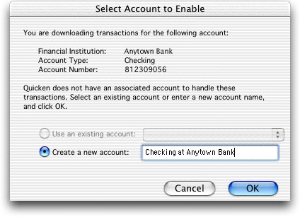
To use an account that you manually enter transactions or perform QIF imports, click here.
To create a new account, click and type the account name here.

Your downloaded transactions are displayed in the Download Transactions window.

Note: You only need to select the account for this first download. After the account is activated for Web Connect account access, future downloads download to this account automatically.

KEEPING YOUR QUICKEN ACCOUNTS UP TO DATE
Downloading New Transactions
- Choose Online menu → Download Transactions.
- Choose the account name from the account pop-up menu.
- Click Download. Quicken launches your default browser and takes you to Bath State Bank’s web site.
- Log in to your financial institution’s Web site and download the transactions into Quicken. Quicken automatically displays the downloaded data in the Download Transactions window.
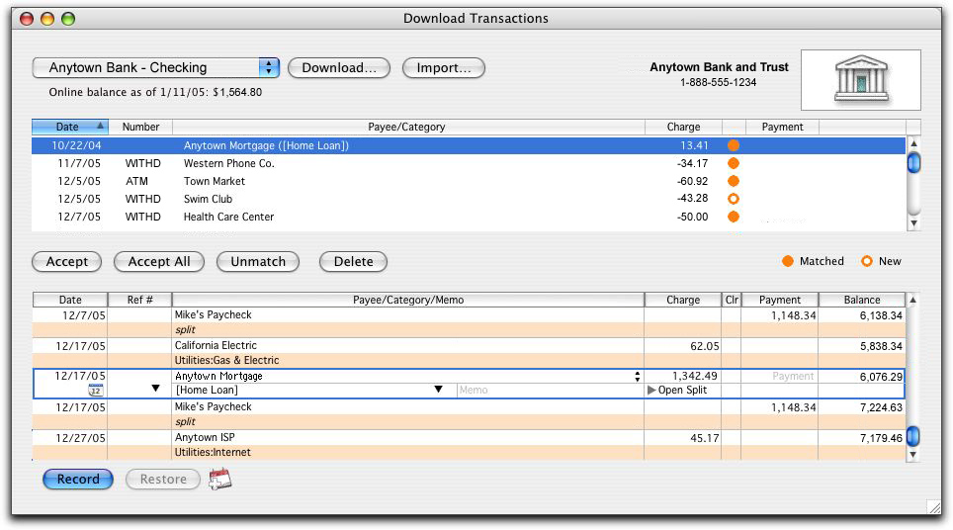
Working with your Downloaded Transactions
- Click to select each transaction that you want to add in your register. You can hold down the SHIFT key and click additional transactions to select multiple transactions. If you make a mistake and want to deselect a transaction, click it again.
- Click Accept to record the selected transactions, or Accept All to record all transactions. The accepted items are added to your register, marked C (cleared), and removed from the transaction list.

CONGRATULATIONS, YOU ARE SET UP AND READY TO USE QUICKEN!

