Getting Started with Transaction Download for

Quicken 2006 for Mac – Web Connect
Refer to this guide for instructions on using Quicken for Mac’s online account services to save time and automatically keep your records up to date.


This guide includes the following sections:
Set up a Quicken Account and Download Transactions for the First Time, page 2—Explains how to create a new Quicken account and download transactions.
Keeping your Quicken Accounts Up-to-Date, page 3—Explains how to download transactions on an ongoing basis.

Information You’ll Need to Get Started
To download your transactions with Quicken, you must have Internet access. In addition, to complete setting up your Quicken accounts with transaction download you will need to log into the Bath State Bank web site.
This guide will show you how to setup and download your accounts. For step-by-step help, choose Quicken Help from the Help menu.

Important: First, get the latest program updates!
From the Quicken 2006 menu, select Check for Updates and follow the on-screen instructions.
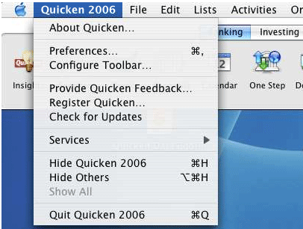

Set up a Quicken Account and Download Transactions for the First Time
The following steps explain how to activate your existing Quicken account(s) or create one or more new Quicken accounts for Web Connect online access.
- Log into your financial institution’s Web site and follow the instructions provided on the Web site to download your account information into Quicken.
- Download the Web Connect file (.qfx file extension) and save it to your desktop.
- Open Quicken and from the File menu, select Import Web Connect. Locate the Web Connect file you just saved to your desktop and click Open.
- Click the Use an existing account radio button and select an account that you manually enter transactions or perform QIF imports. Or, click the Create a new account radio button and type a name for the account, and then click OK.
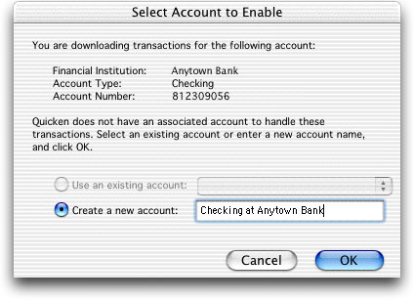
The first radio button, Use an existing account lets you download into an account that you manually enter transactions or perform QIF imports.
Note: You only need to select the account for this first download. After the account is activated for Web Connect account access, future downloads will download to this account automatically.
- Your downloaded transactions are displayed in the Download Transactions window.
- Refer to the following section to download transactions from now on.

Keeping Your Quicken Accounts Up-to-Date

- From the Online menu, select Download Transactions.
- Choose Bath State Bank from the Financial Institution pop-up menu.
- Choose the account name from the Account pop-up menu.
- Click Download. Quicken will launch your default browser and take you to Bath State Bank’s web site.
- Log into Bath State Bank’s web site and download the Web Connect file (.qfx file extension). Quicken will automatically locate the file on your desktop and display the downloaded data from this file in the Download Transactions window.

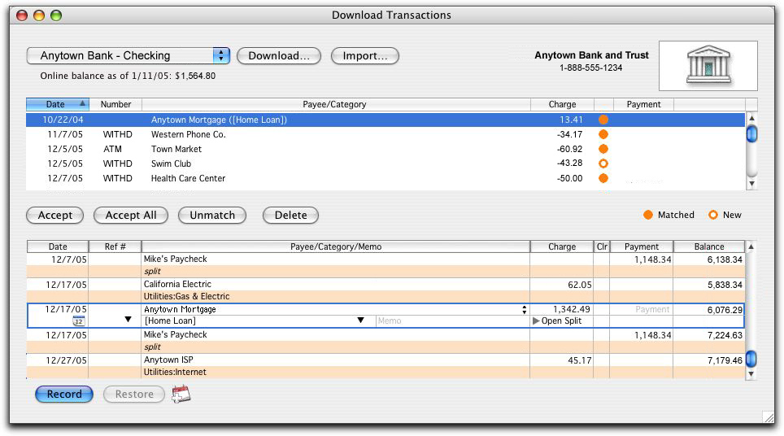

Working with your downloaded transactions
- Select each transaction that you want to add to your register. You can hold down the Command key and click additional transactions to select multiple transactions. If you make a mistake and want to deselect a transaction, click it again.
- Click Accept to record the selected transactions, or Accept All to record all transactions. The accepted items are added to your register, marked C (cleared) and removed from the transaction list.

