Getting Started Guide: Transaction Download for QuickBooks 2009-2011 Windows®
Refer to the Getting Started Guide for instructions on using QuickBooks’ online account services; to save time, improve accuracy, and keep your records updated. This guide will specifically show you how to download transactions and make online payments directly from QuickBooks.



The Getting Started Guide includes the following information:
Information You will Need to
Get Started- Provides a listing of the information you will need to have on hand before downloading transactions into QuickBooks.
Setting Up Online Account Access- How to set up transaction downloads for your QuickBooks accounts.
Keeping Your QuickBooks Accounts Updated- How to automatically download transactions into QuickBooks.
Sending Online Payments- How to make online payments from within QuickBooks.

Information You’ll Need to Get Started

Before you enable your QuickBooks accounts to download transactions and make online payments, you will need to contact Bath State Bank for the following information:

Customer ID
Personal Identification Number (PIN) or password

Note: There is no online transaction download capability with the QuickBooks Simple Start edition.

Setting Up Online Account Access

- Go to the Banking drop down menu → Online Banking → Setup Account for Online Access.
- You will be prompted to close all QuickBooks windows, click YES to continue.

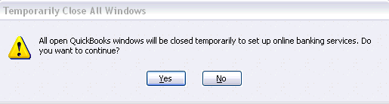

- The Set Up Account for Online Services window will appear →click the drop down arrow for options to choose from or create a new account → click next to continue.
Select <Add New> to create a new account in QuickBooks

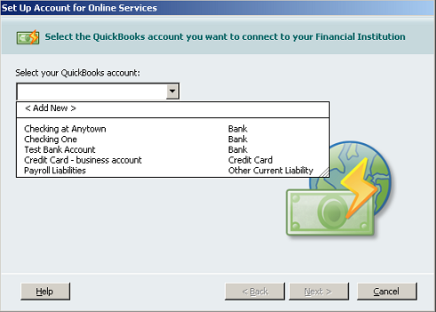
Choose from the existing accounts in QuickBooks.

- Select your financial institution →click next.
- Bath State Bank supports both Direct Connect and Web Connect downloads within QuickBooks. You will be prompted to select your preferred method.

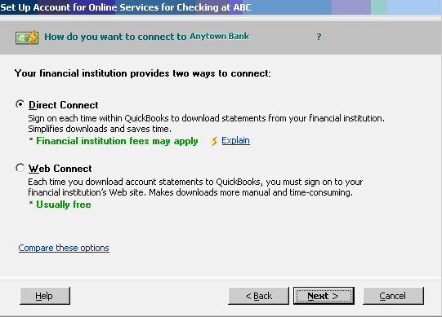
To learn more and compare these options click the hyperlink for detailed information or contact your financial institution.

**If you have selected Web Connect please skip ahead to step 9**
If you have select Direct Connect, please continue to step 6

- If you selected Direct Connect and have your Customer ID and Password, if not please contact your financial institution →click Sign In to continue.
If you do not have your Customer ID and Password, please contact you financial institution

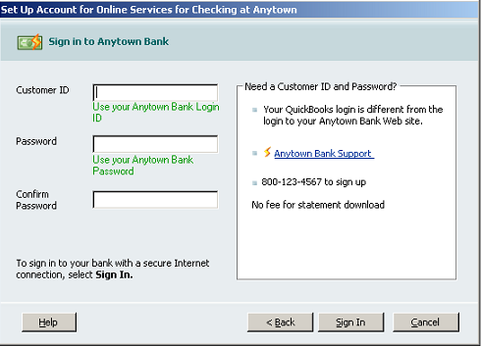
- QuickBooks will retrieve a list of accounts available for you to download →select the account you want to download and follow the remaining on-screen instructions.

- When the first download completes successfully your account setup is complete →click Finish → QuickBooks will now launch the Online Banking Center.
If your financial institution supports Online Bill Payment, check the Activate Online Bill Payment box below to enable the service within QuickBooks.

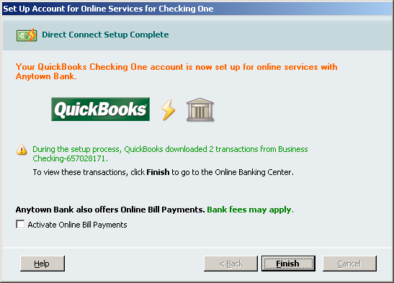

Move past step 9 for an overview on Keeping Your QuickBooks Accounts Updated and Sending Online Payments.

- If you selected Web Connect you will see the window below →click on Go to My Bank’s Web site (www.BathStateBank.com) →QuickBooks will launch a web browser directly to Bath State Bank’s web site.

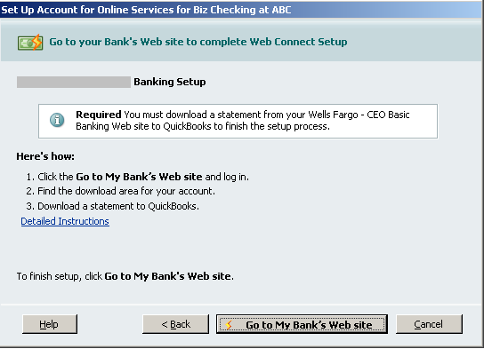

For further information on this process click the Detailed Instructions hyperlink.

See the following sections for an overview on Keeping Your QuickBooks Accounts Updated and Sending Online Payments.

Online Banking Center

The Online Banking Center has been updated in QuickBooks 2009. You can manage all your online banking tasks from within the Online Banking Center.
To get to the Online Banking Center go to the Banking drop down menu →Online Banking → Online Banking Center

Access the interactive in product Video Tutorial for step by step instructions.
Select you financial institution.
View account information such as, account type and balance.

Click hyperlink to view items downloaded in more detail.
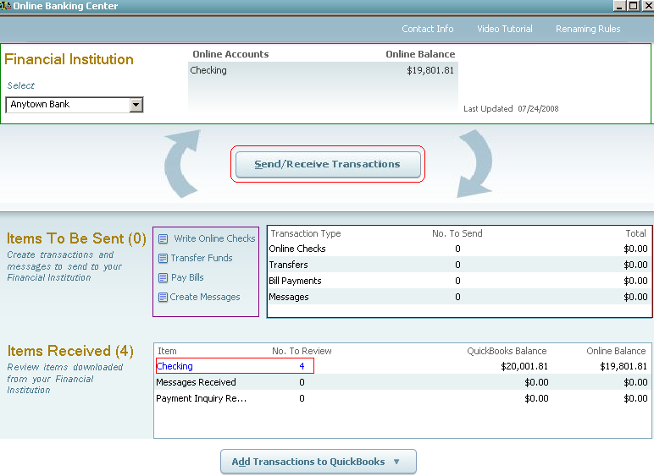
Go online to Send/Receive Transaction.
Write checks, transfer funds, pay bills all from within the Online Banking Center.
View a list of all transfers, checks, payments, and messages that are waiting to be sent.
Click to Add Transactions to QuickBooks.

Keeping QuickBooks Accounts Updated

- Once in the Online Banking Center (Banking drop down menu → Online Banking →Online Banking Center), you can download transactions to keep you QuickBooks accounts up to date.
- Click the Send/Receive Transactions → Enter your PIN to download transactions from your financial institution.
- Once transactions are downloaded from your financial institution you can add them to QuickBooks by clicking the Add Transactions to QuickBooks button.
Click Send/Receive Transaction to download transactions from your financial institution.

To update QuickBooks with the downloaded transactions, click Add Transactions to QuickBooks.

- The Add Transactions To QuickBooks window will appear, with a summary of transactions downloaded from your financial institution.
- Click on the transaction you wish to add to QuickBooks → follow the prompts to insure accuracy → click Add to QuickBooks.

Select the Payee if an expense and select the account the transaction should point to.
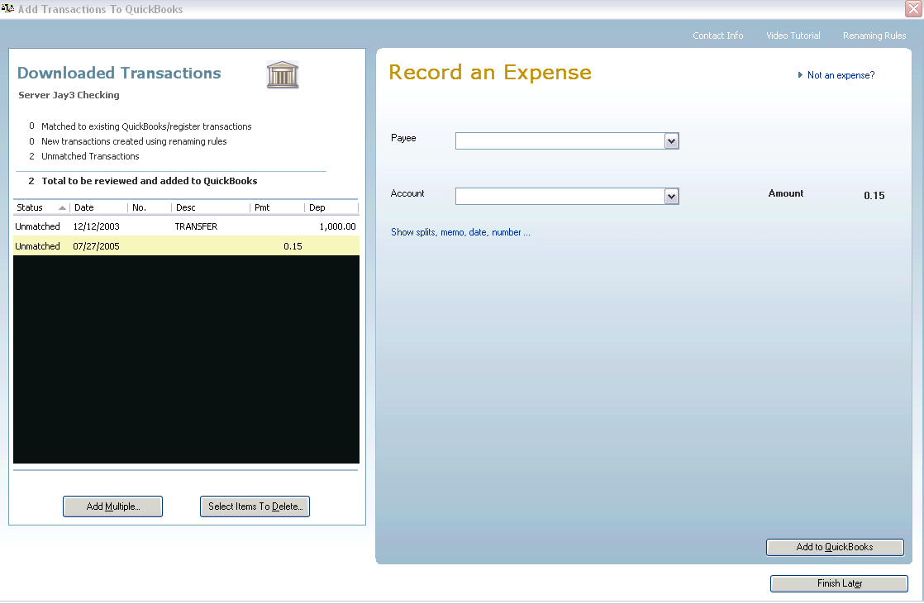
Summary of all transactions downloaded into QuickBooks from your financial institution.
Add Multiple transactions at one time.

Sending Online Bill Payments

If you have enabled the service within your QuickBooks, you can create online payments directly from your check register.
To get to your Check Register go to the Banking dropdown menu → click Use Register

- Once at the check register → enter the payment date with sufficient lead time (if unsure of how much time is needed contact your financial institution) → for the transaction Type type the “S” for SEND, which will auto-populate.

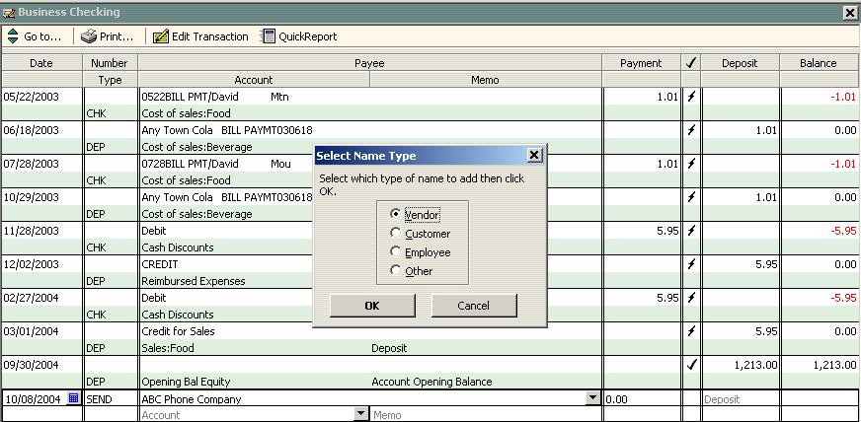

- Enter the Payee (if it is a new Payee select <Add New> and follow the steps to add the payee to QuickBooks).

- Enter Payment amount, Account the payment should post to, and any other information needed for accuracy → click Record.

- To send your online payment, go to the Online Banking Center → you will see the queued payments listed under Items To Send → Click Send/Receive Transaction → enter your PIN to send the payment.

Online Bill Payments waiting to send.

