Getting Started Guide:
Transaction Download for QuickBooks® for Mac 2009-2011 using Direct Connect or Web Connect.

Refer to this guide for instructions on using QuickBooks’s online account features to save time, improve accuracy, and keep your records up to date. Specifically, we will show you how to download transactions in the QuickBooks for Mac 2009-2011.
BATH STATE BANK – BANK BY MOUSE

This guide includes the following sections:
- Information You’ll Need to Get Started, page 1—Explains the information you will need to have before downloading transactions with QuickBooks.
- Set Up Online Account Access, page 2—Explains how to set up transaction download for your QuickBooks account.
- Add or Match transactions to the register, page 6—Describes how to download transactions on an ongoing basis.
.

Information You will need to Get Started
Before you enable your QuickBooks accounts to download transactions you will need to contact your financial institution for the following information:
- Customer ID
- Personal Identification Number (PIN) or password
- Routing Number - Financial institutions are identified by a unique nine-digit number called the routing number. It is used to send checks and electronic transactions to the right place for processing. Please contact your financial institution for this information.

Set Up Online Account Access
The following steps explain how to enable an existing or new QuickBooks account for transaction download.
- From the menu, choose Banking > Online Banking Setup.
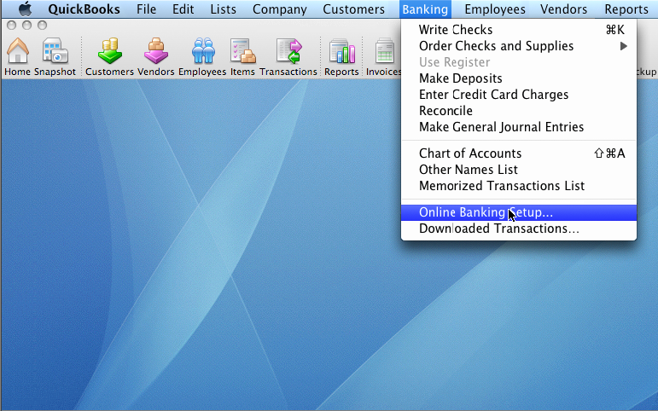

- Select your financial institution from the drop down list. 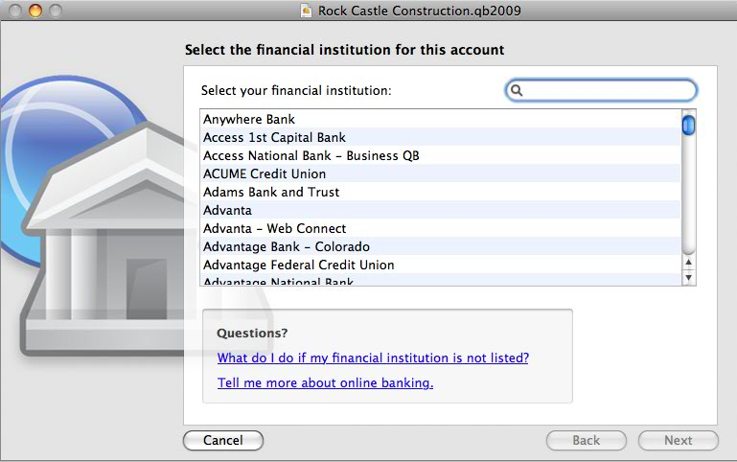
- If your financial institution offers Direct Connect download, you will be given the option to select the Direct Connect method. Click Next to continue.
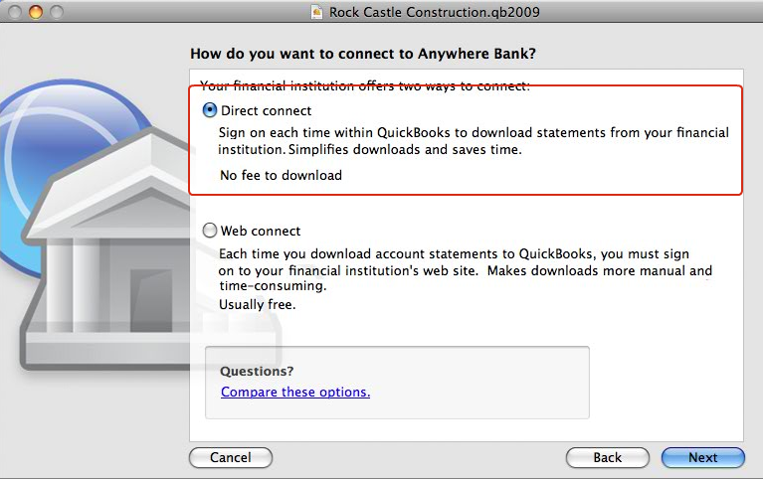

- If you have account login please select Yes and click Next. If you selected Web Connect go to Step 8
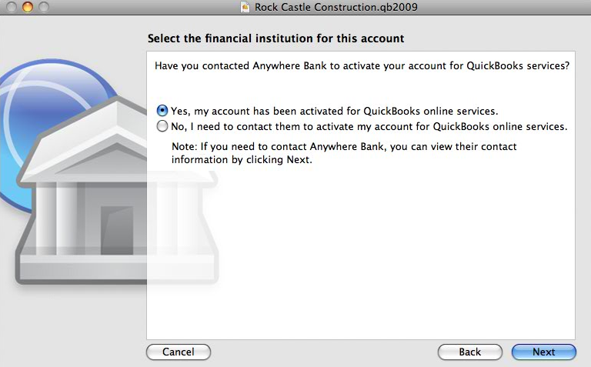

- Enter your CustomerID and Password and click Sign In.
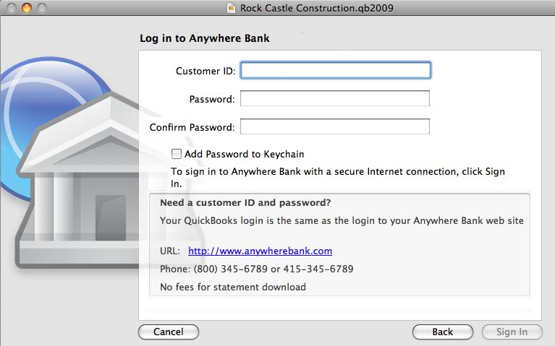

- If the login is successful you will be shown a list of accounts that are available for download from your financial institution. For each account on this list please select an existing Quickbooks account to download into, if any, or choose to set up a new account.
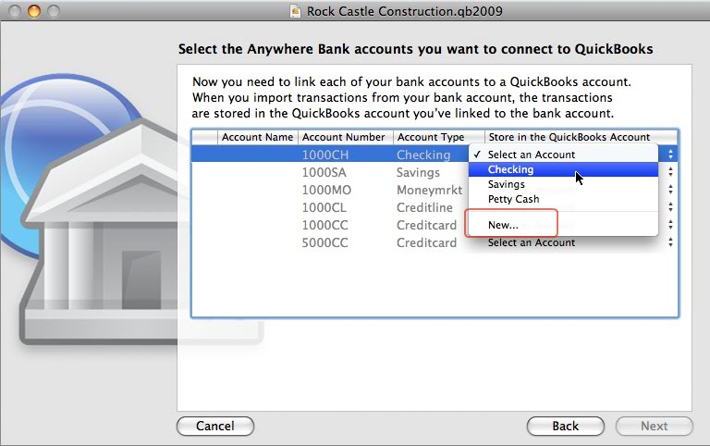

- When the first download completes successfully your account setup is complete. Click Done.
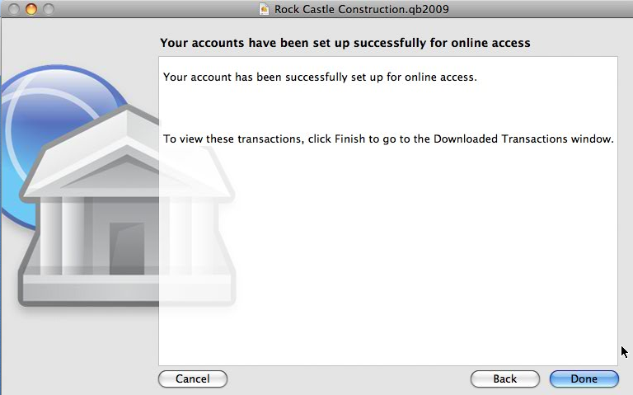
- If you selected Web Connect you will see the window below. Click on the website link. This will launch a web browser and take you to your financial institution’s website. Follow instructions to import your statement.
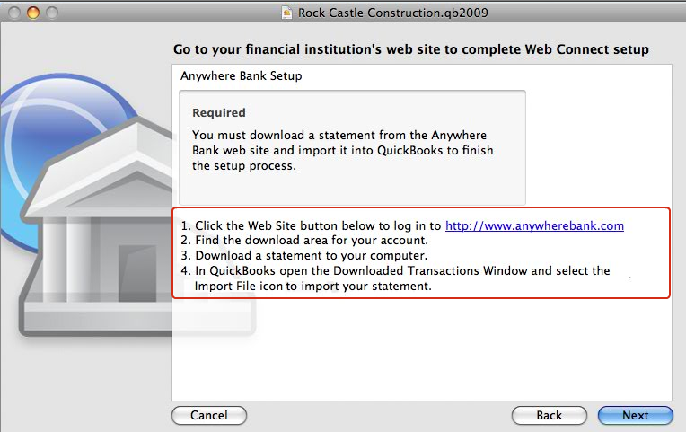

Add or Match Transactions into the Account Register

- Click Align Windows to open the appropriate Register (or select any downloaded transaction from the list)
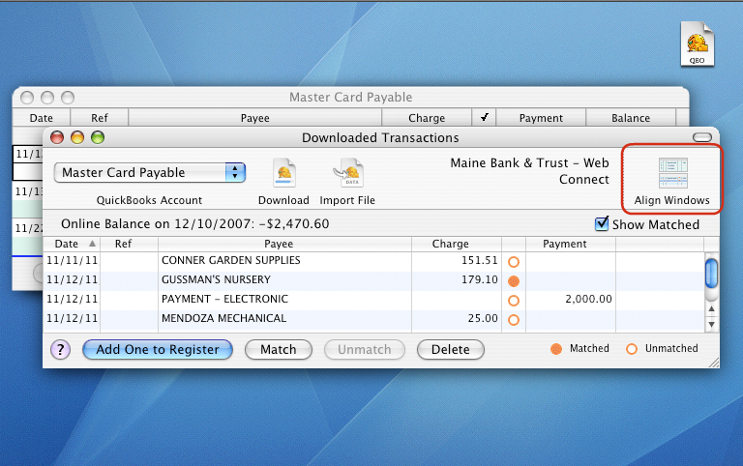

- Select each downloaded transaction and click Add One to Register. Next, assign an Income or Expense Account and click Record to save each transaction in the register
Note: The Match status is indicated by orange circle icon. A matched transaction will not add a duplicate of a transaction you already manually entered in your register.
Override Match Settings: If the transaction should have matched a transaction that you manually entered in the register then click the Match button. Conversely, if it’s new, but was incorrectly matched to an existing record, then click Unmatch to add it as an additional transaction.

- Once all downloaded transactions have been matched you can safely remove matched transactions in the downloaded transactions window.

